Millersview Annual Wheat Tour Millersview Gym
May 2, 2024

Agenda

8:00 - 8:30

8:30 – 8:50

8:50 – 9:40

9:40– 10:30

10:30 -11:20

11:20- 11:50

11:50-12:20

12:20- 12:45

12:45-1:25

1:30- 2:20

2:20-2:40

2:40- 3:40

3:40 – 4:00

Registration and Welcome: Brook Nervig & Sarita Short

Harvest Weather Outlook: BJ Baule
Laws and Regulations for Pesticide Applicators: Cory Pence
Hessian Fly Management and Integrated Pest Management Updates in Small Grains: Tyler Mays & Gregory Wilson
Grain Marketing Update: Dr. Mark Welch

Plant Variety Protection Act: Jeff Wright & Mark Hodges

Lunch

Sponsor Recognition and Texas Wheat Producer’s, FSA, and NRCS Update

Precision Nutrient Management: Dr. Reagan Noland & Producer Panel

Variety Development for Pest/Disease Resistance: Dr. Brett Carver

Move to Wheat Plots

Wheat/Herbicide Plot Demonstration: Dr. Reagan Noland & Dr. Brandon Gerrish

Evaluations and Certification

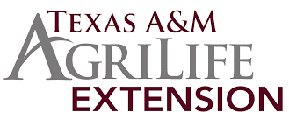
Texas A&M AgriLife Extension Service is an equal opportunity employer and program provider. The Texas A&M University System, U.S. Department of Agriculture, and the County Commissioners Courts of Texas Cooperating.

